Experiment No. 2
SE (CSE) ROLL NO : 10937
Date of Implementation: 05-02-2026
Aim: Implement Data Visualization techniques in Python
Programming Language Used : Python
Upon completion of this experiment, students will be able to
CO2 : Apply various analysis and visualization techniques using modern tools on real-world data
 | Indicator |  | Poor |  | Average | Good
 | Timeline  Maintains submission deadline (2) |  | Submission not done (0) |  | One or More than One week late (1) | Maintains deadline (2)
 | Completion and Organization (2) |  | Many mistakes in documents (0) |  | Document is just acceptable (1) | Completed whole document and neatly organized (2)
 | Program Performance (2) |  | Could not perform at all (0) |  | Implemented few parts (1) | Full implementation (2)
 | Knowledge  In depth knowledge of the Experiment (4) |  | Unable to answer questions(0) |  | Unable to answer few questions (1-2) | Able to answer all questions with proper explanation (3-4)
Assessment Marks :
 | Timeline
 | Completion and Organization
 | Program Performance
 | Knowledge
TOTAL :

EXPERIMENT | 2
Aim | Implement Data Visualization techniques in Python
Theory | Principles of Effective Data Visualization  Effective data visualization aims to communicate information clearly, accurately, and efficiently. The key principles include:  Clarity: Visuals should be simple and easy to understand without ambiguity. Accuracy: Data must be represented truthfully without distortion or misleading scales.  Relevance: The visualization should match the nature of the data and the objective of analysis.  Consistency: Uniform colors, scales, and labels improve readability. Simplicity: Avoid unnecessary decorations (chartjunk) that distract from insights.  Comparability: Enable easy comparison across categories or time periods.  Benefits of Data Visualization  Data visualization provides several advantages:  Simplifies complex datasets into understandable visuals Helps in quick identification of patterns, trends, and outliers Improves decision-making through visual insights  Enhances communication of results to technical and non-technical audiences Supports exploratory data analysis (EDA) and hypothesis generation  Types of Visualizations  Charts are commonly used to represent categorical or time-based data. Bar Charts: Compare values across categories  Line Charts: Show trends over time  Pie Charts: Represent proportional data or percentages  Graphs are mainly used for distribution analysis and relationship exploration. Scatter Plots: Show relationships between two numerical variables Histograms: Display frequency distribution of numerical data  Box Plots: Summarize data using quartiles and detect outliers Word Clouds: Visualize text data based on word frequency  Maps are used when data has a geographical component.  Geographic Maps: Display data across locations (countries, states, cities) Heat Maps: Represent data intensity or correlation using color gradients  Dashboards are interactive visual platforms that combine multiple visualizations.  Provide real-time insights  Allow filtering, drilling down, and comparison Widely used in business intelligence and analytics

Data Visualization Tools
Several tools are available for creating effective visualizations: Microsoft Excel: Easy-to-use tool for basic charts and dashboards Tableau: Advanced visualization tool with drag-and-drop features
Power BI: Business intelligence tool for interactive reports and dashboards
Implementati on | Using Excel :  - Load the Dataset. Download Students Performance in Exams dataset from Kaggle  - Open the CSV file in Microsoft Excel  - Calculate average Math, Reading, Writing scores and show in bar chart  - Count number of Male and Female students and show in pie chart  - Select first 10 student records. Show the score trend by line chart Using Python :  - Load any data set that is available in Python such as IRIS data set, TITANIC data set or TIPS data set or any other data set available.  - Show bar chart (average feature values), stacked bar chart, line graph, Histogram, scatter plot, box plot, parallel coordinate plot, heatmap, QQ plot, violin plot, pair plot, KDE plot, bubble chart
Conclusion | Comment on the different graphs output.
Post Lab Questions: | - What is KDE plot?  - What is violin plot?  - What is bubble chart?

Implementation in Excel:

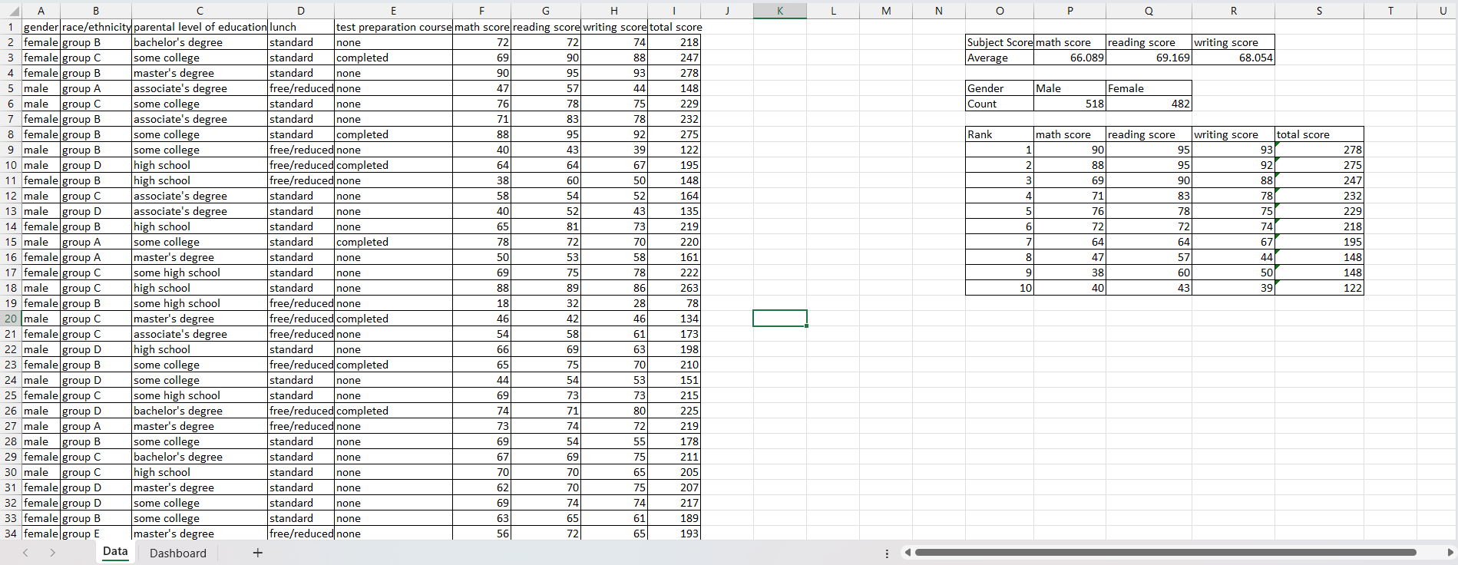
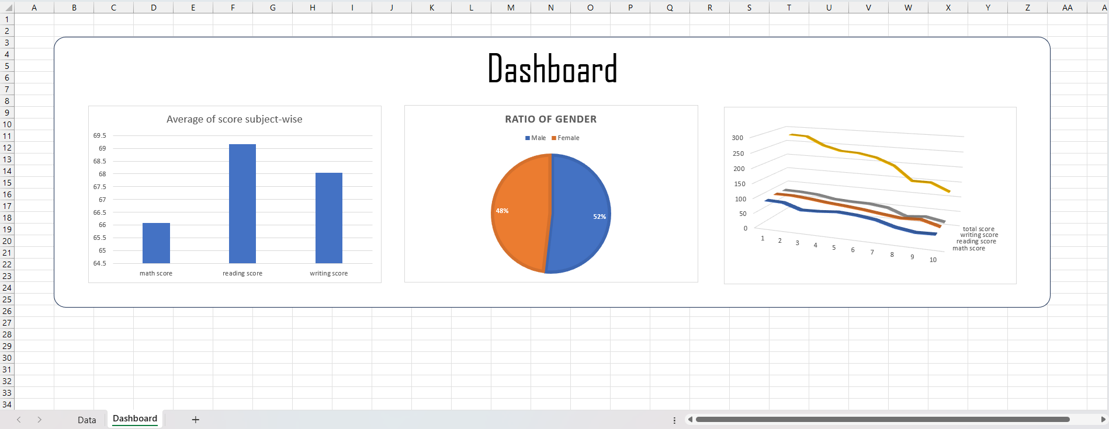

Implementation in Python:

Installing and Importing Libraries
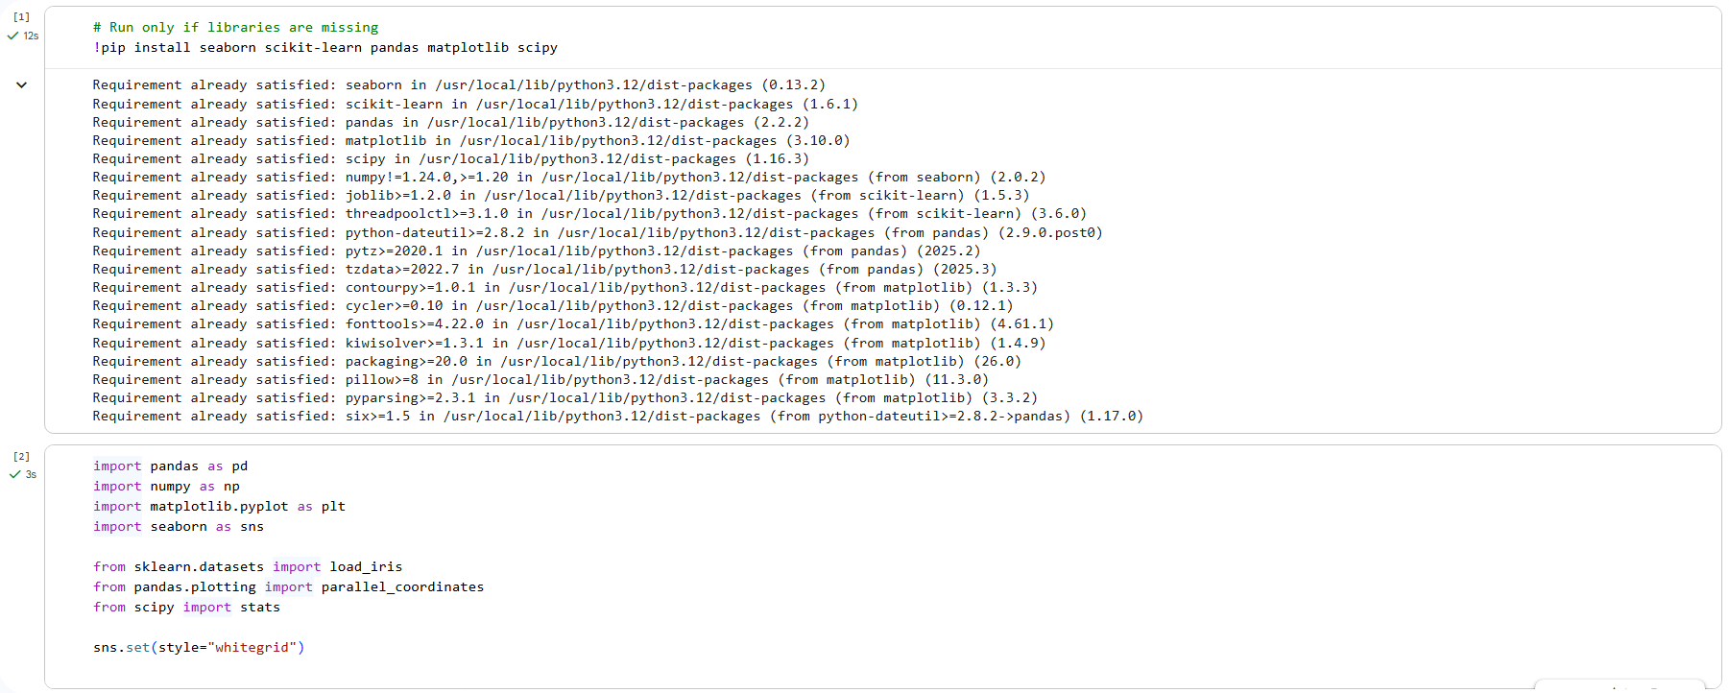

Loading Dataset
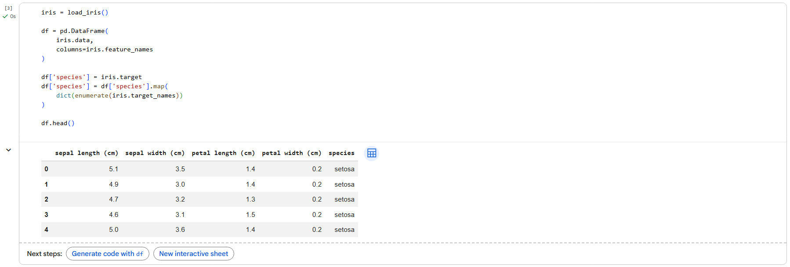

Bar Chart
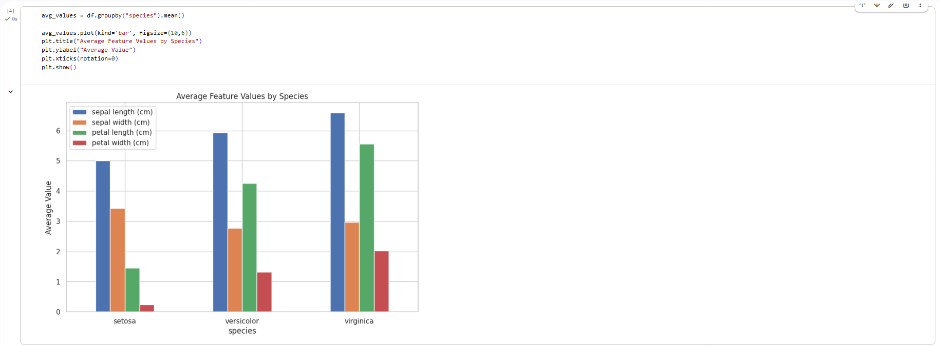

Stacked Bar Chart
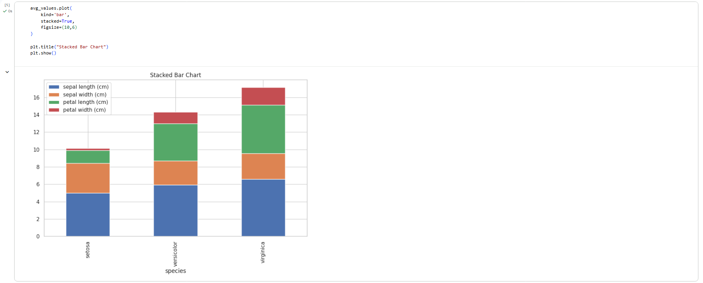

Line Graph
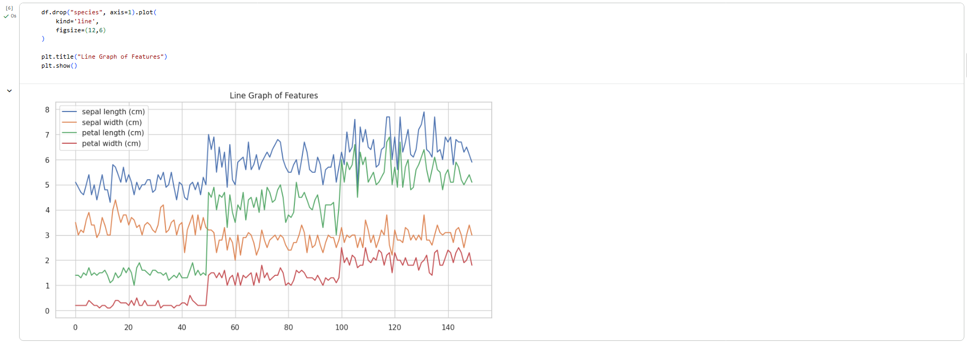
Histogram
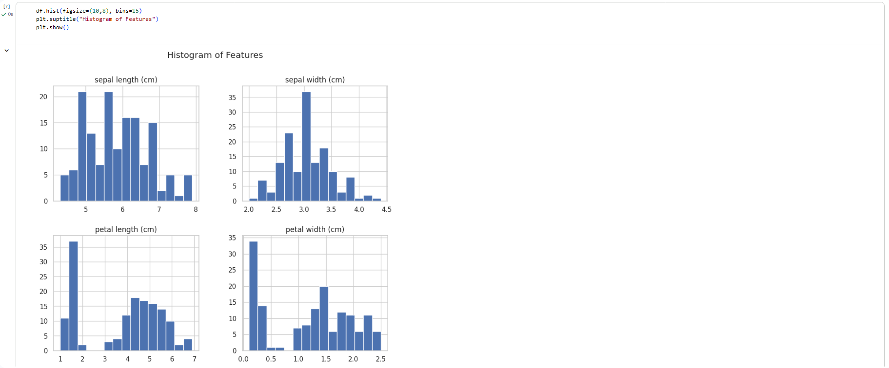
Scatter Plot

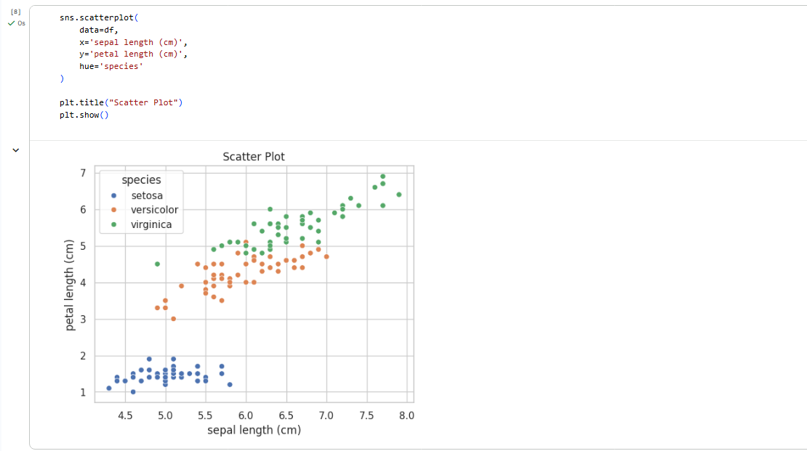

Box Plot
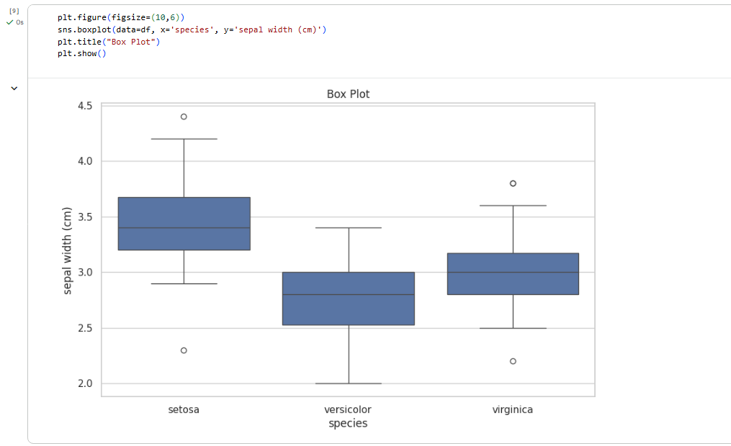

Parallel Coordinate Plot
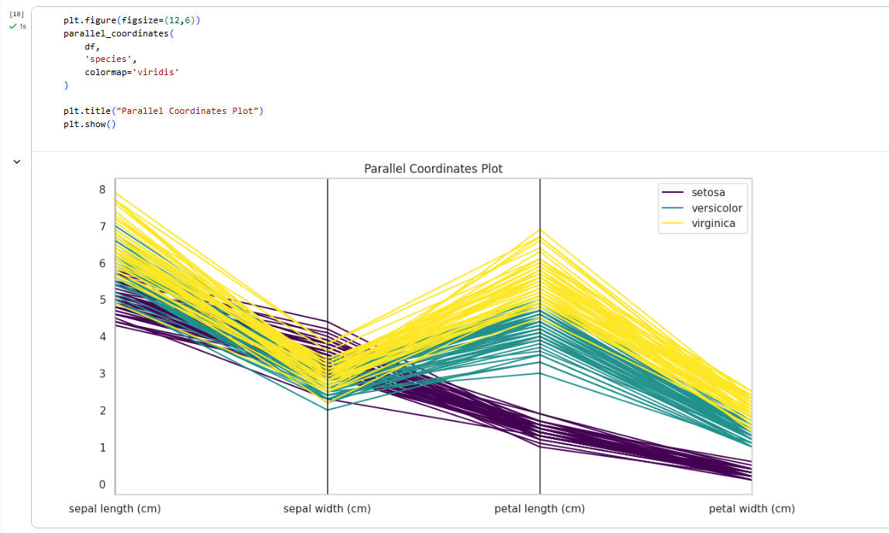

Heat Map
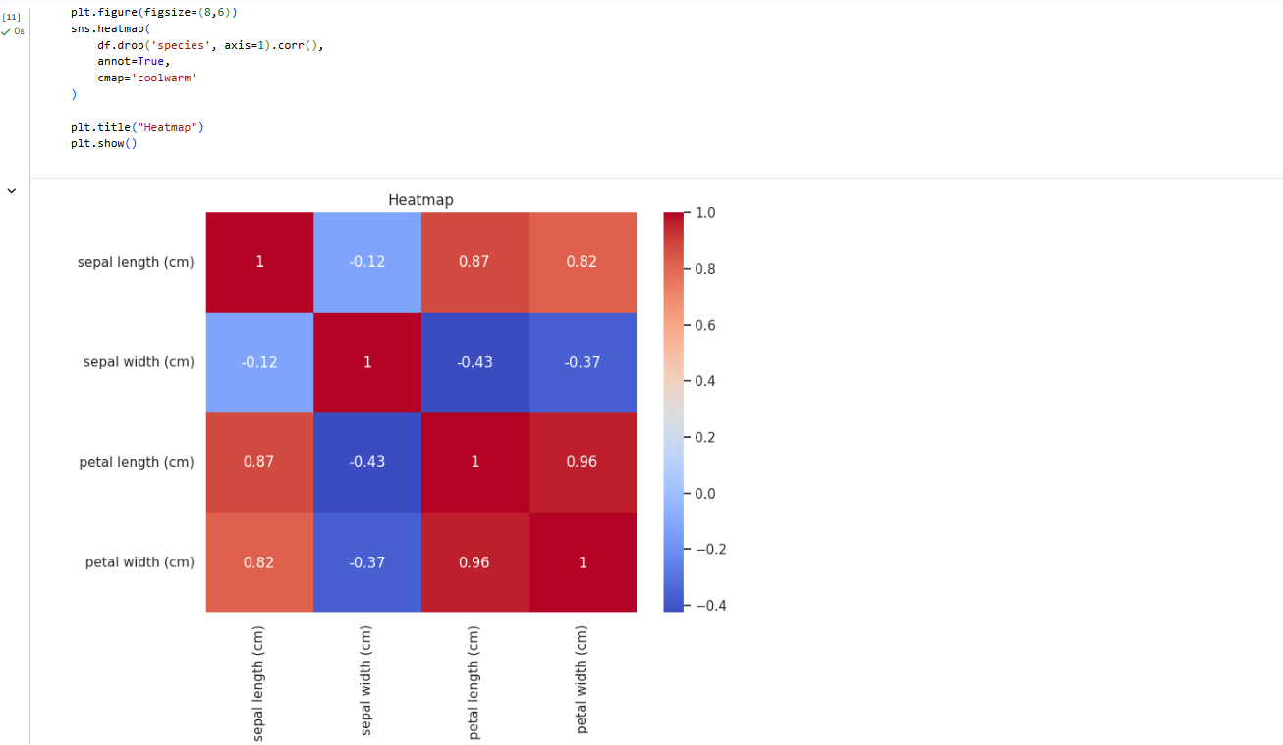

QQ Plot
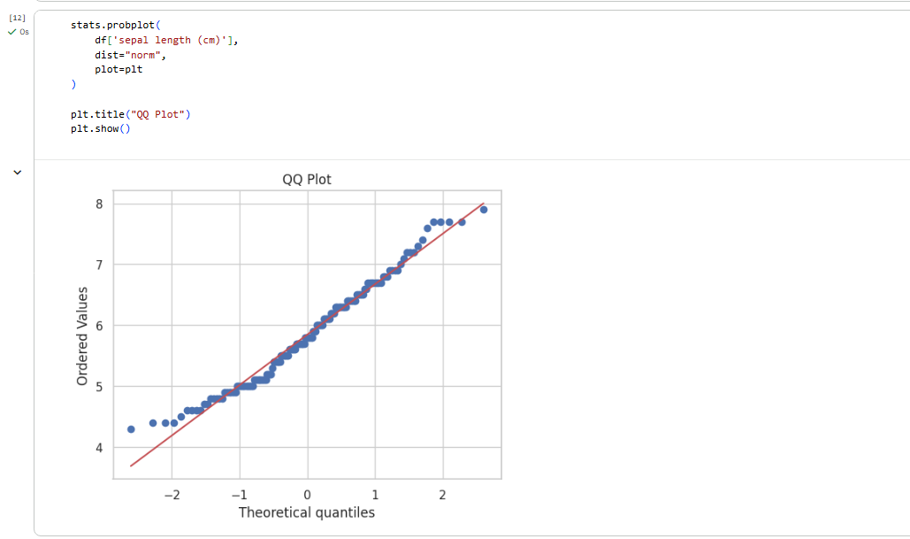

Violin Plot
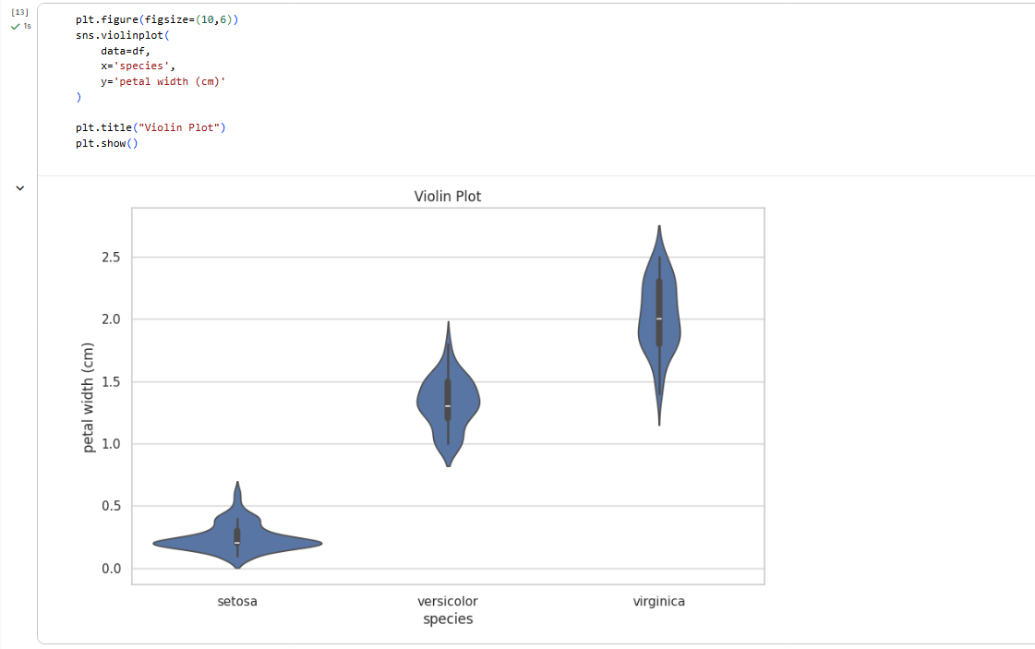

Pair Plot

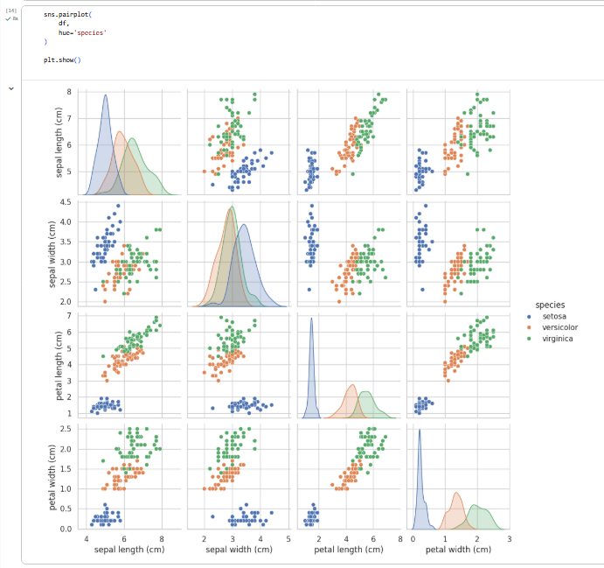

KDE Plot

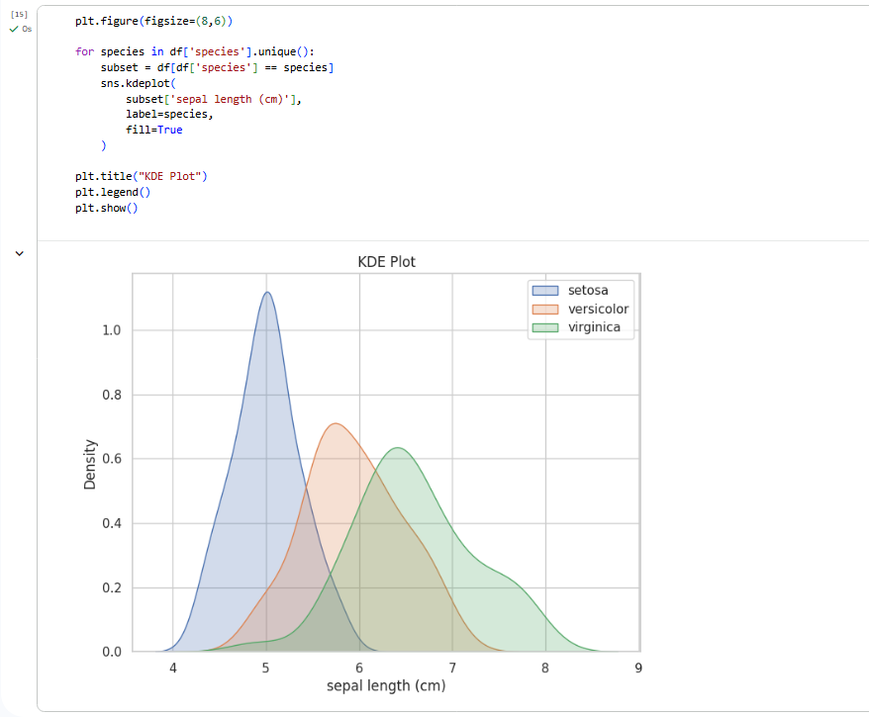

Bubble Chart

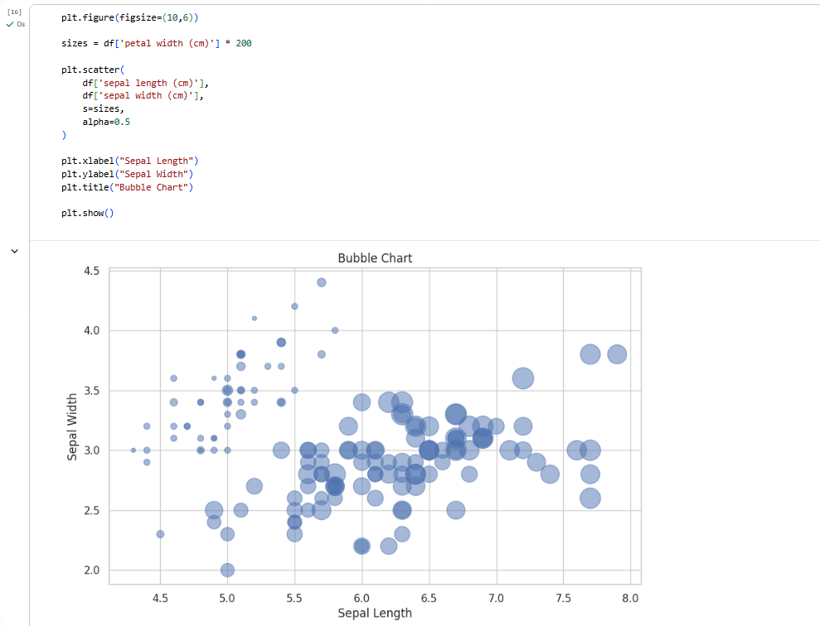

Post Lab Questions:
1. What is a KDE plot?
A Kernel Density Estimation (KDE) plot is a graph that shows the probability density (distribution) of a continuous variable using a smooth curve instead of bars. It is used to identify data shape, peaks, skewness, and whether data is normally distributed.
2. What is a violin plot?
A violin plot combines a box plot + KDE to display both summary statistics and data distribution. It shows median, spread, and density, helping compare distributions across categories.
3. What is a bubble chart?
A bubble chart is an enhanced scatter plot where bubble size represents a third variable. It is used to analyze multi-variable relationships, detect clusters, and understand feature importance.

Conclusion:
This practical shows how multiple visualization techniques can help to explore a dataset, reveal feature relationships, identify distributions and correlations, detect clusters, and determine important variables to provide a better understanding of the data.

